Name: Poorab Gangwani

Section: 2B

Enrollment #: CS191092

**LAB # 5**

**Experimental verification of Kirchhoff’s Voltage and Current laws**

**Lab Objectives:**

* To experimentally verify Kirchhoff’s Voltage Law (KVL)
* To experimentally verify Kirchhoff’s Current Law (KCL)

**Apparatus Required:**

* Power Supply
* Digital Multi-meter
* Resistors
* Connecting wires
* Bread board

**PRE-LAB:**

**Branch:**

A branch represents a single element such as resistor or voltage source. In other words, a branch represents any two-terminal element.

**Node:**

A node is the point of connection between two or more branches.

**Loop:**

A loop is any closed path in a circuit.

Looking at the fig. 5.1, we have 5 branches, 3 nodes and 3 loops.

The general formula is given by,

**b=l + n – 1**

eq. 5.1

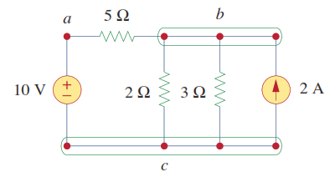

*Fig. 5.1: branches, nodes & loops*

**Kirchhoff’s Voltage Law (KVL):**

*“The algebraic sum of all voltages around any closed path(loop) in an electric circuit is zero”*

Consider a series circuit as shown in fig. 5.2

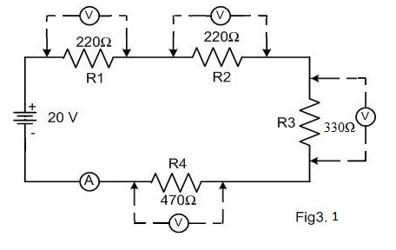



*Fig. 5.2: KVL example*

Vs = -20V VR1=3.54V VR2=3.54V VR3=5.32V VR4=7.58V

Applying KVL,

-Vs+ VR1+ VR2+ VR3+ VR4=0

-20V+3.54V+3.54V+5.32V+7.58V= 0

**Kirchhoff’s Current Law (KCL):**

*“The algebraic sum of all currents entering any node in an electric circuit is zero.”*

*OR*

*“The sum of currents entering a node is equal to the sum of currents leaving a node”*

For the circuit in fig. 5.3 the KCL equation is given by,

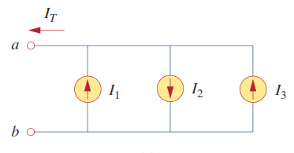- IT + I1 - I2 + I3 = 0

IT + I2 = I1 + I3

*Fig. 5.3: KCL example*

**IN-LAB**

**LAB TASK 1: Verification of KVL**

1. Develop the circuit shown in **fig. 5.4** on a bread board.
2. Take **R1 = 1 kΩ R2 = 4.7 kΩ R3 = 2.2 kΩ**  and **R4 = 8.2 kΩ**
3. Switch on the DC power supply and set its output voltage to **10V.**
4. Measure voltage drops across resistances R1, R2, R3 and R4 using a digital multimeter and record them in **table 5.1.**
5. Write down loop equations for the circuit in **fig. 5.4.**

Equation for loop C: Vs – I 1 x R1 – R3(I1-I2)=0

Equation for loop D: 0 – I2R2 – I2R4 – R3(I2-I1)

1. Using the measured values of voltage drops across resistances (**table 5.1**), apply Kirchhoff’s voltage law (KVL) to loops C and D of **fig. 5.4**.

Algebraic sum of all voltage drops for loop C:

Vs + V1 – V2 – V3 =0 => 0.059

Algebraic sum of all voltage drops for loop D:

0-V2-V4-V3 = 0 => 11.833

**LAB TASK 2: Verification of KCL**

1. Use Digital Multimeter and record the current readings IR3 and IR4 in **table 5.2** as shown in **fig. 5.5.**
2. Apply Kirchhoff’s current law (KCL) to node A of the circuit shown in **fig. 5.5**, to theoretically calculate the current through resistor R1 (IR1). Show your calculation below:

R1 = 1k

R2 = 4.7k

R3 = 2.2k

R4 = 8.2k

IR4 = 607.176UA = 0.000607176 A

IR3 = 3.46Ma = 0.00346 A

iR1 = IR2 + IR3

IR2 = IR4

IR1 = 0.00346 + 0.000607176

IR1 = 0.004067176

**Calculated IR1 using KCL** =_0.004067176 A_____________

1. Now measure the current through resistor R1 (IR1), as shown in **fig. 5.6.**

**Measured IR1 using KCL** = __0.004067176 A ____________

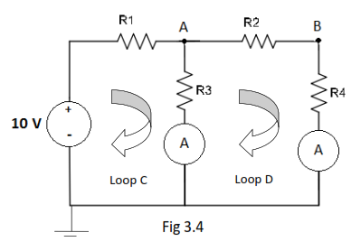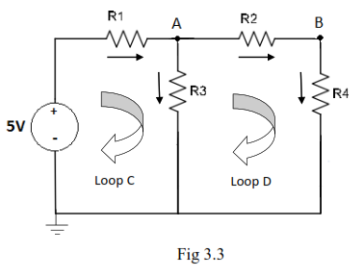*Fig. 5.4: lab task 1 Fig. 5.5: lab task 2*

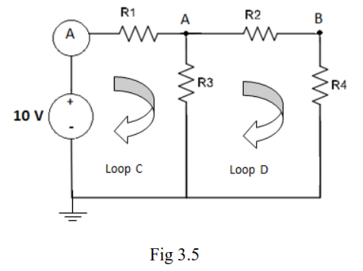



*Fig. 5.6: lab task 2*

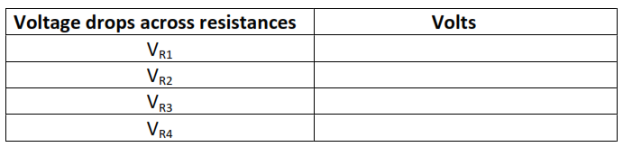*Table 5.1: lab task 1*

Vr1 = 3.6

Vr2 = 2.4

Vr3 = 6.341

Vr4 = 3.092

*Table 5.2: lab task 2*

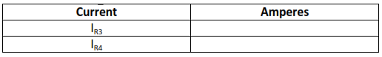

Ir3 = 3.46mA

Ir4 = 607.176uA

**(lab task 3 was Optional as informed by madam sidra)**

**LAB TASK 3**

**Verification of KVL** (Develop the circuit shown in fig. 5.4 on a bread board)

**Verification of KCL** (Develop the circuit shown in fig. 5.5 on a bread board)

1. Take **R1 = 10 kΩ R2 = 8 kΩ R3 = 22 kΩ**  and **R4 = 15 kΩ**
2. Switch on the DC power supply and set its output voltage to **20V.**

*Table 5.1: lab task 3*

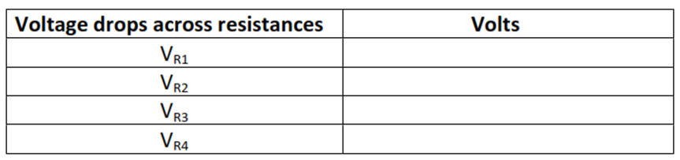

*Table 5.2: lab task 2*

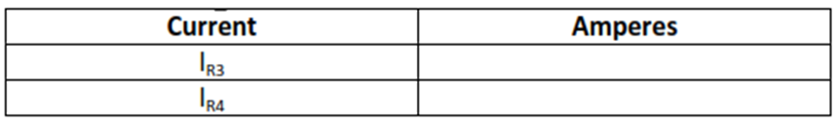

1. Algebraic sum of all voltage drops for loop C:

_____________________________________

1. Algebraic sum of all voltage drops for loop D:

_____________________________________

**Calculated IR1 using KCL** =______________

Now measure the current through resistor R1 (IR1), as shown in **fig. 5.6.**

**Measured IR1 using KCL** = ______________

**Conclusion:**

___________________________________________________________________

___________________________________________________________________

___________________________________________________________________

Name: Poorab Gangwani

Enrollment #: CS191092

**POST-LAB ASSIGNMENT # 5**

Q. 1) Find the voltage V1, V2 and V3 by applying KVL.

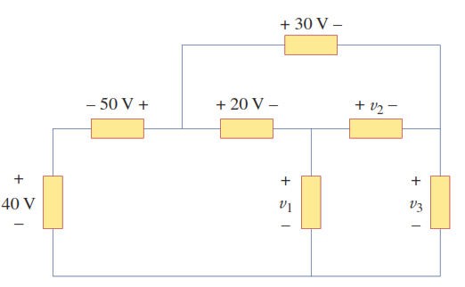

Loop 1 :40V +50V -20V -V1

V1= 70V

Loop 2: 30V -20V -V2

V2= 10V

Loop 3 : -V2 -V3 +V1 =0

-10 -V3 +70 =0

V3=60V

Q. 2) Find the currents I1, I2, I3 and I4 by applying KCL.

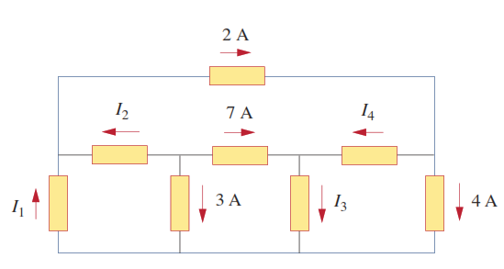-3A – I2 – 7A = 0

I2 = -10A

7A + I4 = I3

2A = 4A + I4

I4 = -2A

I3 = 5A

I1 + I2= 2A

I1 = 12A